Changing the “From” email address in Outlook
- Open Outlook
- Go to Reply or New (Image 1)
- Go to “Options” (image 2)
- Choose “From” (Image 3)
- Click on “From” near the send button (Image 4)
  - From the scroll down choose or select “Other Email Address”
- Click on “From” (Image 5)
  - Find the right email
  - Press “OK”
- Your “From” should have the right email address (Image 6)

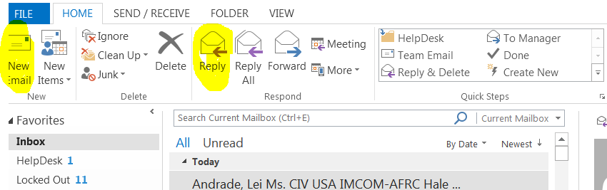
Image 1

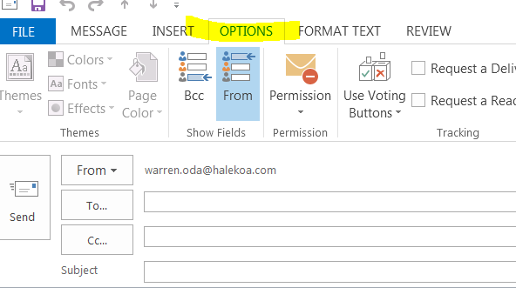
Image 2

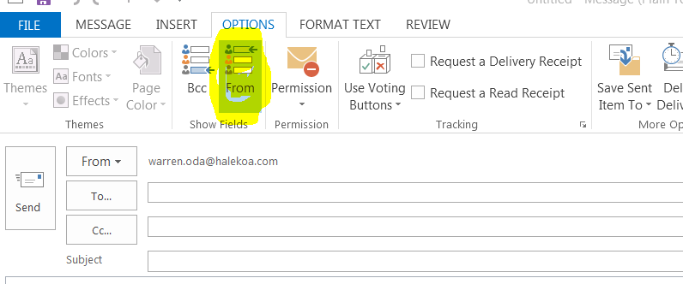
Image 3

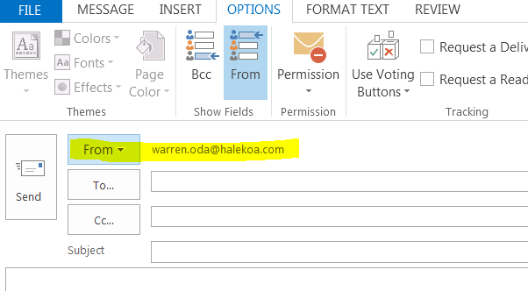
Image 4

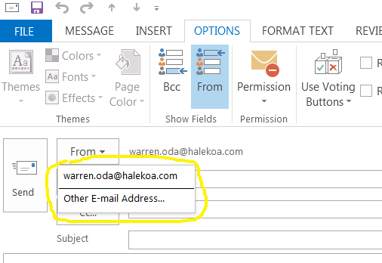
Image 5
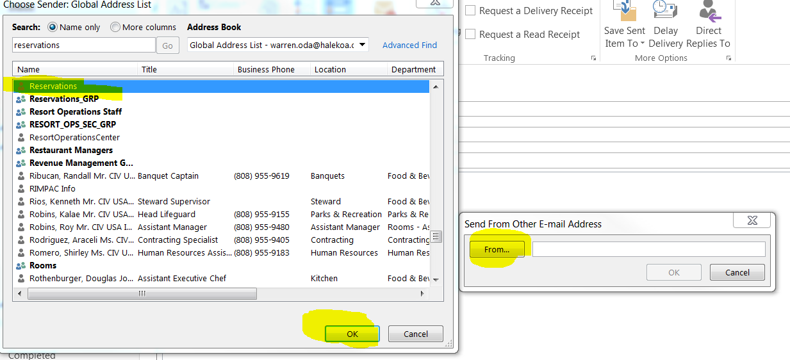
Image 6

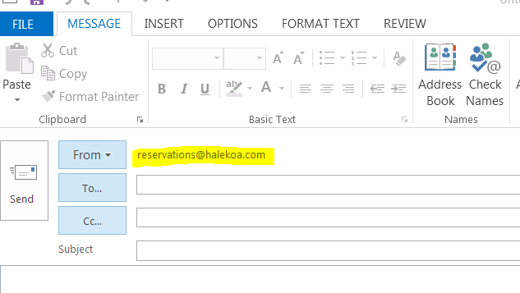
Image 7

