How to Encrypt Email Messages
Purpose: To protect the privacy of an email message. By encrypting email message, this will convert clear plain text message to a scrambled cipher text.
Instructions:
How to Encrypt Email messages (Halekoa Account)
- In Outlook, under the File menu, select Options > Trust Center > Trust Center Settings.
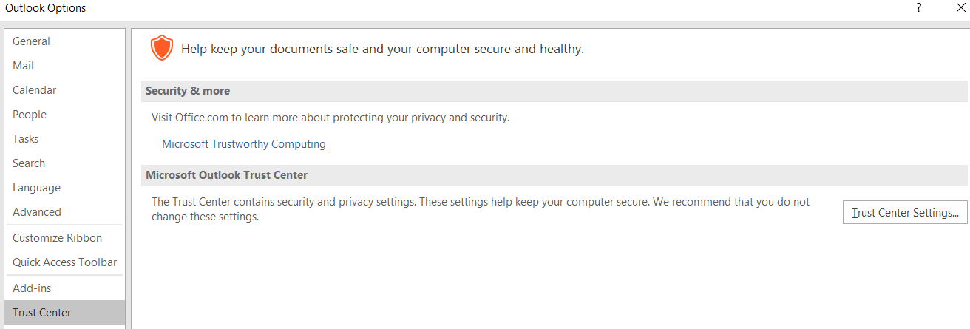
- In the left pane, select Email Security. Under Encrypted e-mail, choose Settings.
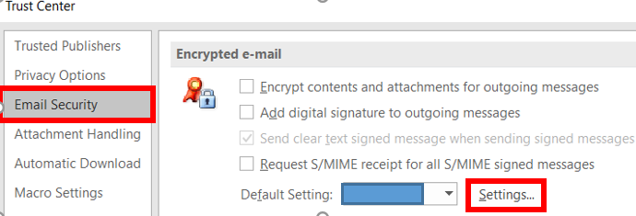
- Under Security Setting Name, create a name.
- Under Certificates and Algorithms, select Choose… add the certificate, then choose OK:
  - Signing Certificate – Signature Certificate
  - Encryption Certificate – Encryption Certificate
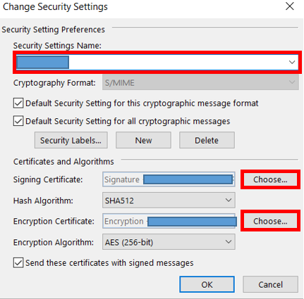

- From the drop-down button, select the best form of Algorithms:
  - Hash Algorithms – SHA 512 (Choose SHA with the highest bit available)
  - Encryption Algorithm – AES (Choose AES with the highest bit available)
- Once completed, choose OK.
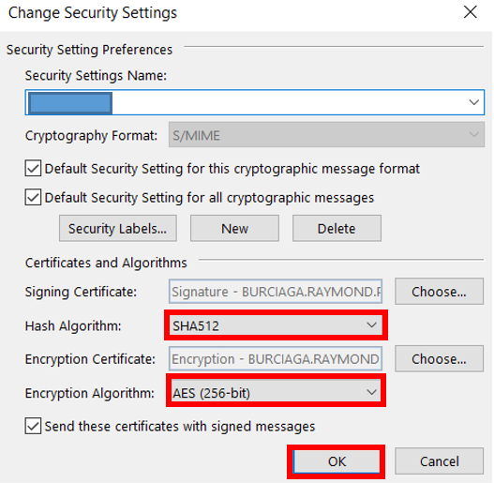
- In an email message, choose Options, under Permissions field, select Encrypt.
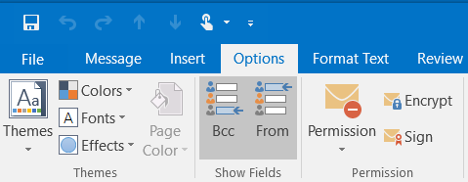
- Finish composing your email and then choose Send.
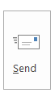

How to Encrypt Email messages (Enterprise Account)
- In an email message, select the ellipsis (…) button, then Encrypt.
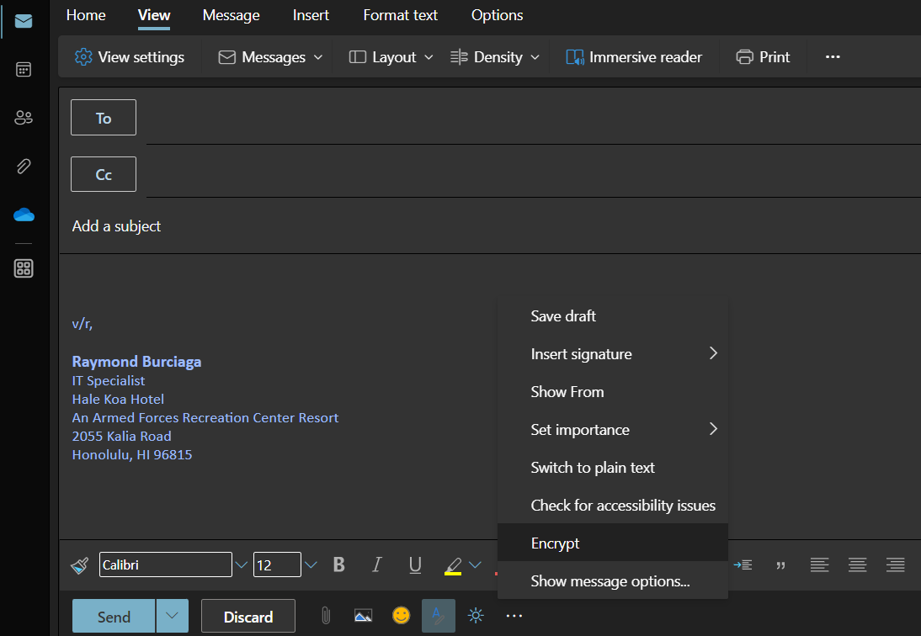

(You should see the encrypt banner above the recipient name)
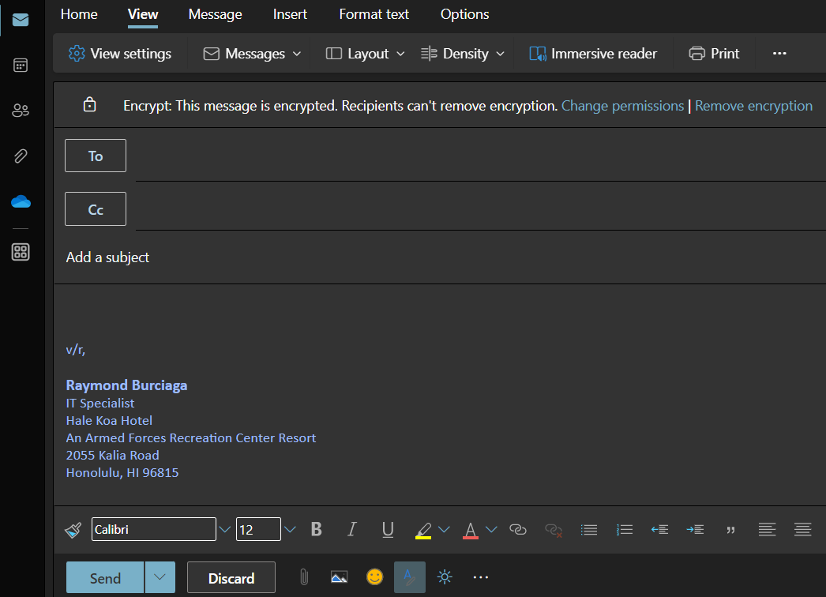

- Finish composing your email and then choose Send.


